**CDAC Mumbai PG-DAC August 24**

**Assignment No- 5**

1. Create a base class BankAccount with methods like deposit() and withdraw(). Derive a class SavingsAccount that overrides the withdraw() method to impose a limit on the withdrawal amount. Write a program that demonstrates the use of overridden methods and proper access modifiers & return the details.

Code:

package org.example.assignment5;

public class BankAccount {

String name;

int accNum;

String branch;

int accBalance;

public BankAccount() {

this.name = "";

this.accNum = 0;

this.branch = "";

this.accBalance = 0;

}

public BankAccount(String name, int accNum, String branch) {

this.name = name;

this.accNum = accNum;

this.branch = branch;

}

public void deposit(int amount) {

this.accBalance += amount;

}

public void withdraw(int amount) {

if (amount < this.accBalance) {

this.accBalance -= amount;

}

else {

System.***out***.println("Insufficient balance");

}

}

public int getAccBalance() {

return accBalance;

}

public void setAccBalance(int accBalance) {

this.accBalance = accBalance;

}

public void displayRecord() {

System.***out***.println("Name: " + this.name);

System.***out***.println("AccNum: " + this.accNum);

System.***out***.println("Branch: " + this.branch);

System.***out***.println("AccBalance: " + this.accBalance);

}

}

package org.example.assignment5;

public class SavingsAccount extends BankAccount {

private int limit;

public SavingsAccount() {

this.limit = 5000;

}

*@Override*

public void withdraw(int amount) {

if (amount < this.limit) {

this.accBalance -= amount - this.getAccBalance();

}

else {

System.***out***.println("Limit Exceeded");

}

}

public int getLimit() {

return limit;

}

public void setLimit(int limit) {

this.limit = limit;

}

}

package org.example.assignment5;

public class Program {

public static void main(String[] args) {

BankAccount a1 = new BankAccount("Rahul", 5648, "Nizamabad");

//a1.displayRecord();

SavingsAccount as1 = new SavingsAccount();

as1.deposit(10000);

as1.withdraw(6000);

as1.displayRecord();

}

}

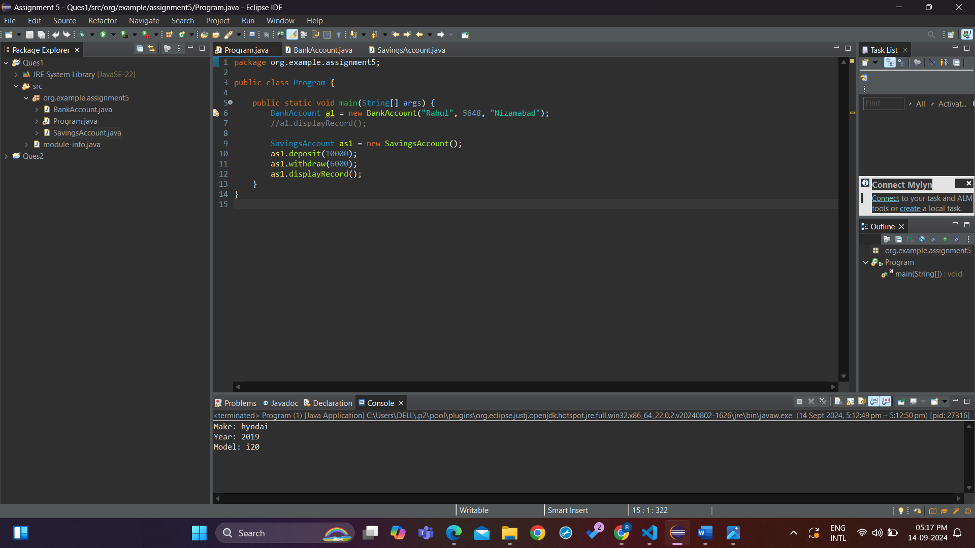

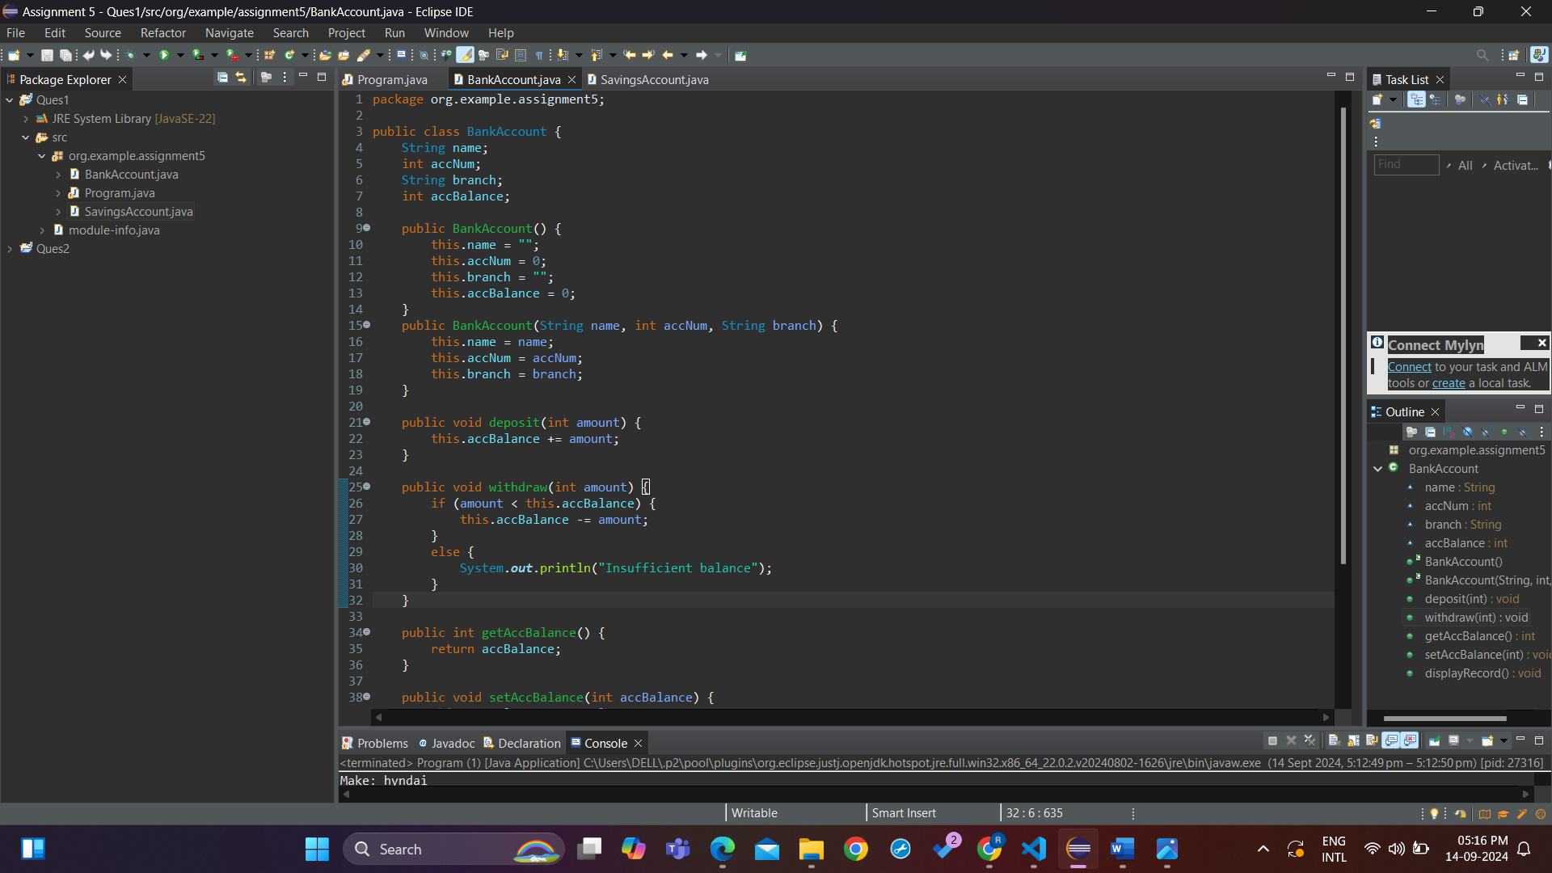

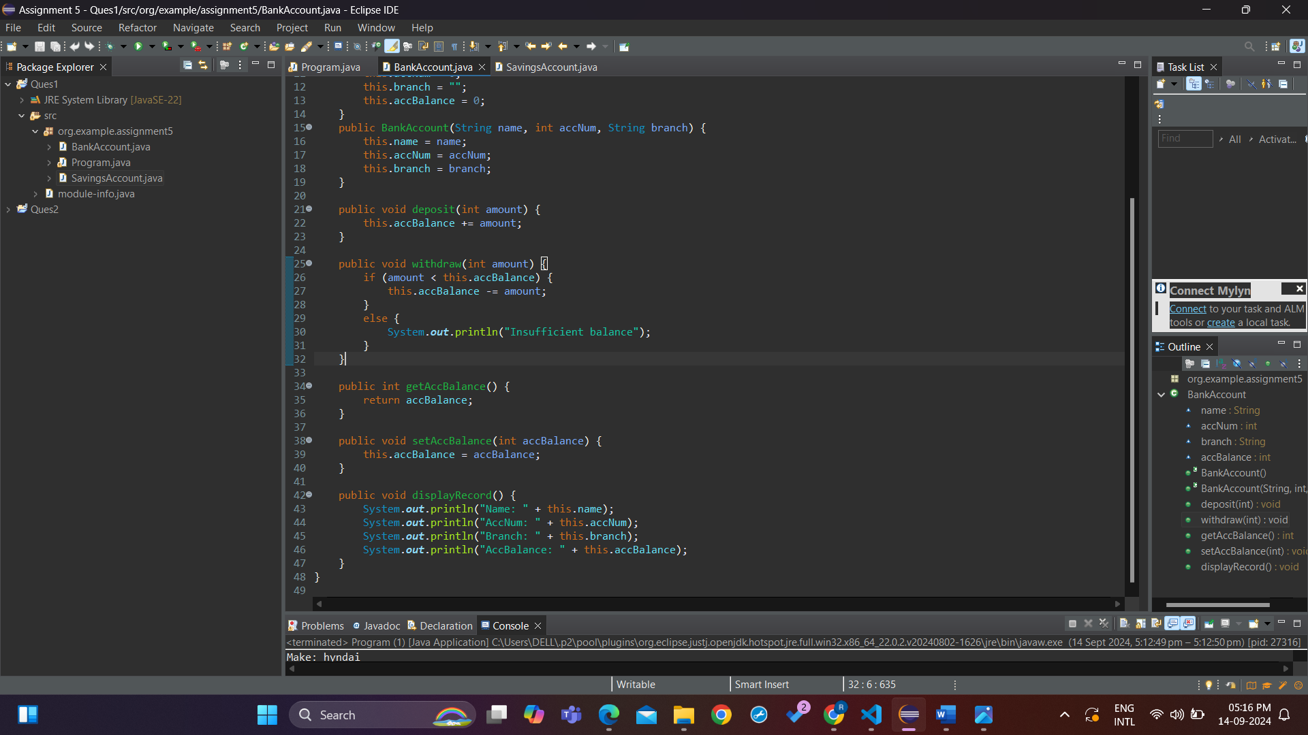

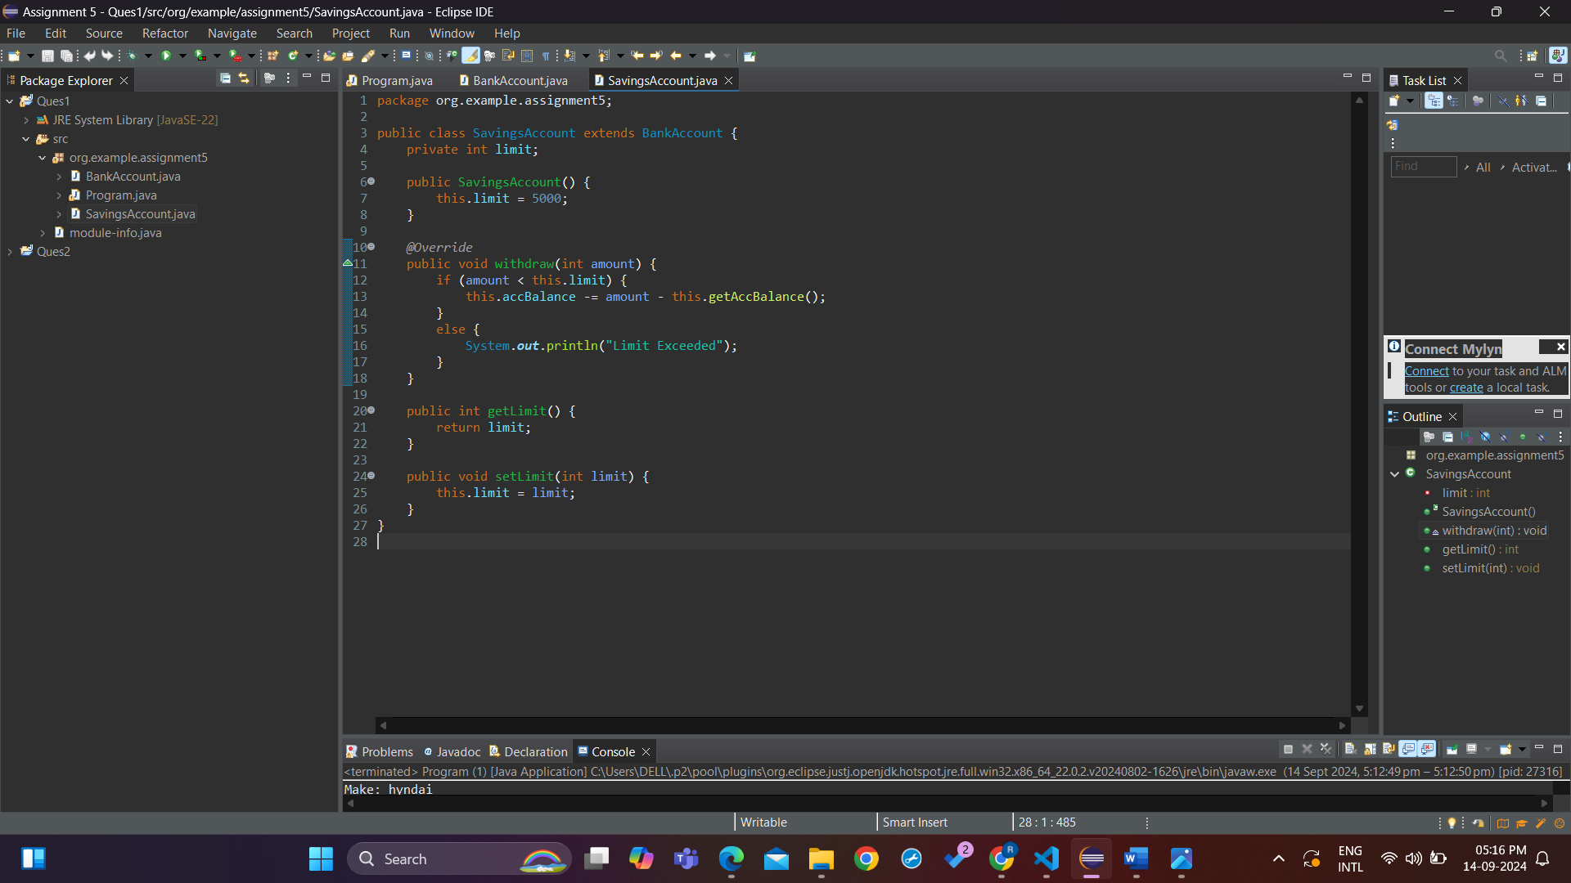

1. Create a base class Vehicle with attributes like make and year. Provide a constructor in Vehicle to initialize these attributes. Derive a class Car that has an additional attribute model and write a constructor that initializes make, year, and model. Write a program to create a Car object and display its details.

Code:

package org.example.ques2;

public class Program {

public static void main(String[] args) {

Car c1 = new Car("hyndai", 2019, "i20");

c1.displayRecord();

}

}

package org.example.ques2;

public class Car extends Vehicle {

private String model;

public Car() {

this.model = "";

}

public Car(String make, int year, String model) {

super(make, year);

this.model = model;

}

public void displayRecord() {

System.***out***.println("Make: " + this.getMake());

System.***out***.println("Year: " + this.getYear());

System.***out***.println("Model: " + this.model);

}

}

package org.example.ques2;

public class Vehicle {

private String make;

private int year;

public Vehicle() {

this.make = "";

this.year = 0;

}

public Vehicle(String make, int year) {

this.make = make;

this.year = year;

}

public String getMake() {

return make;

}

public void setMake(String make) {

this.make = make;

}

public int getYear() {

return year;

}

public void setYear(int year) {

this.year = year;

}

public void displayRecord() {

System.***out***.println("Make: " + this.make);

System.***out***.println("Year: " + this.year);

}

}

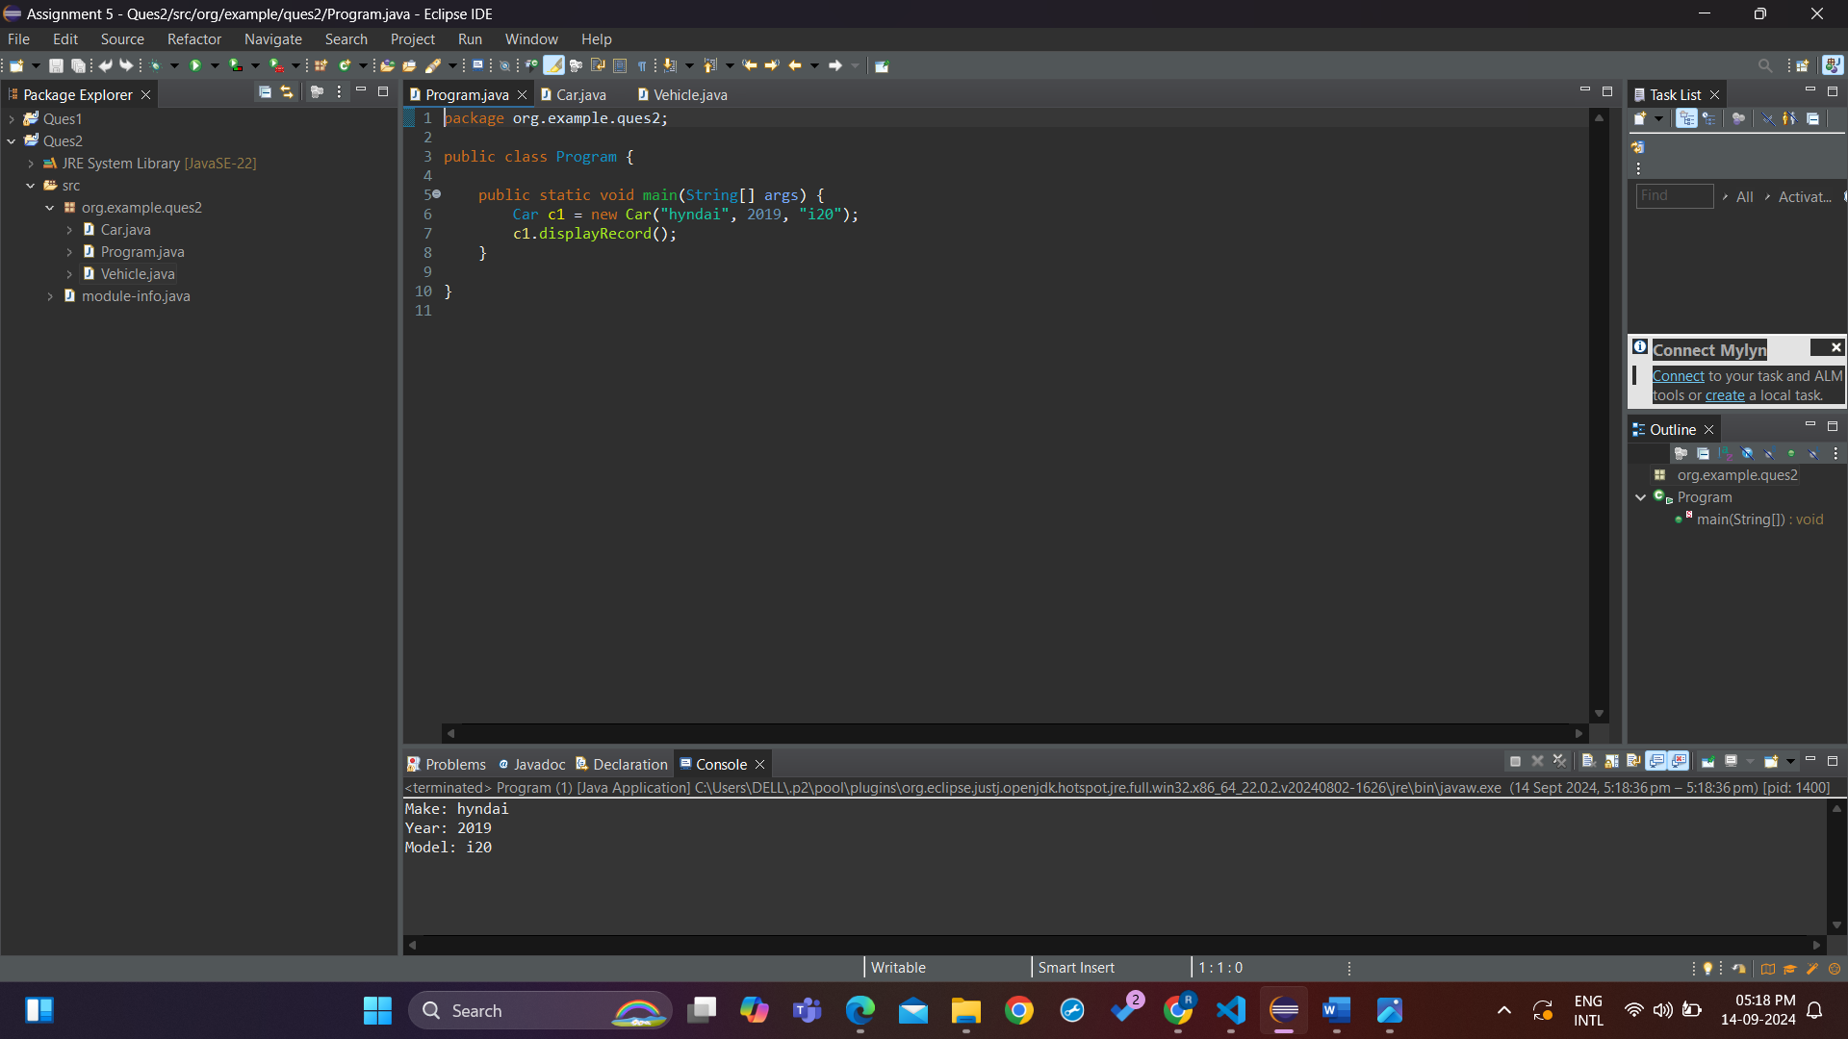

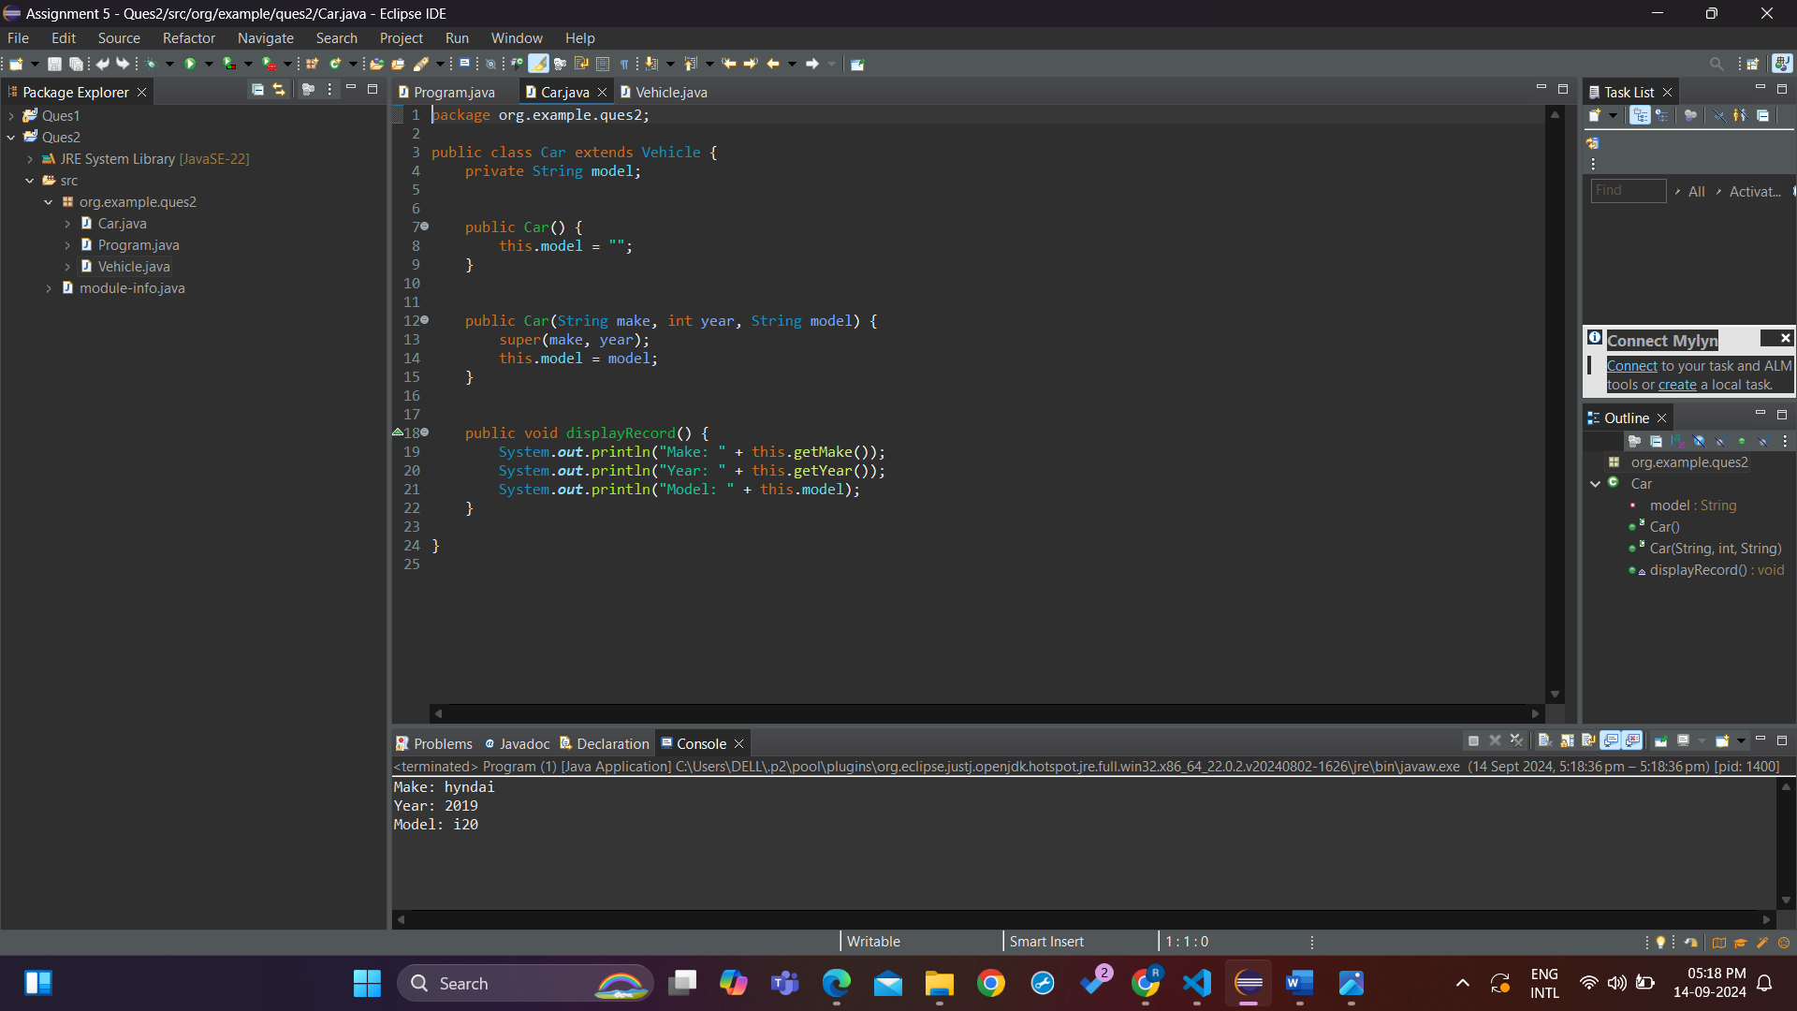

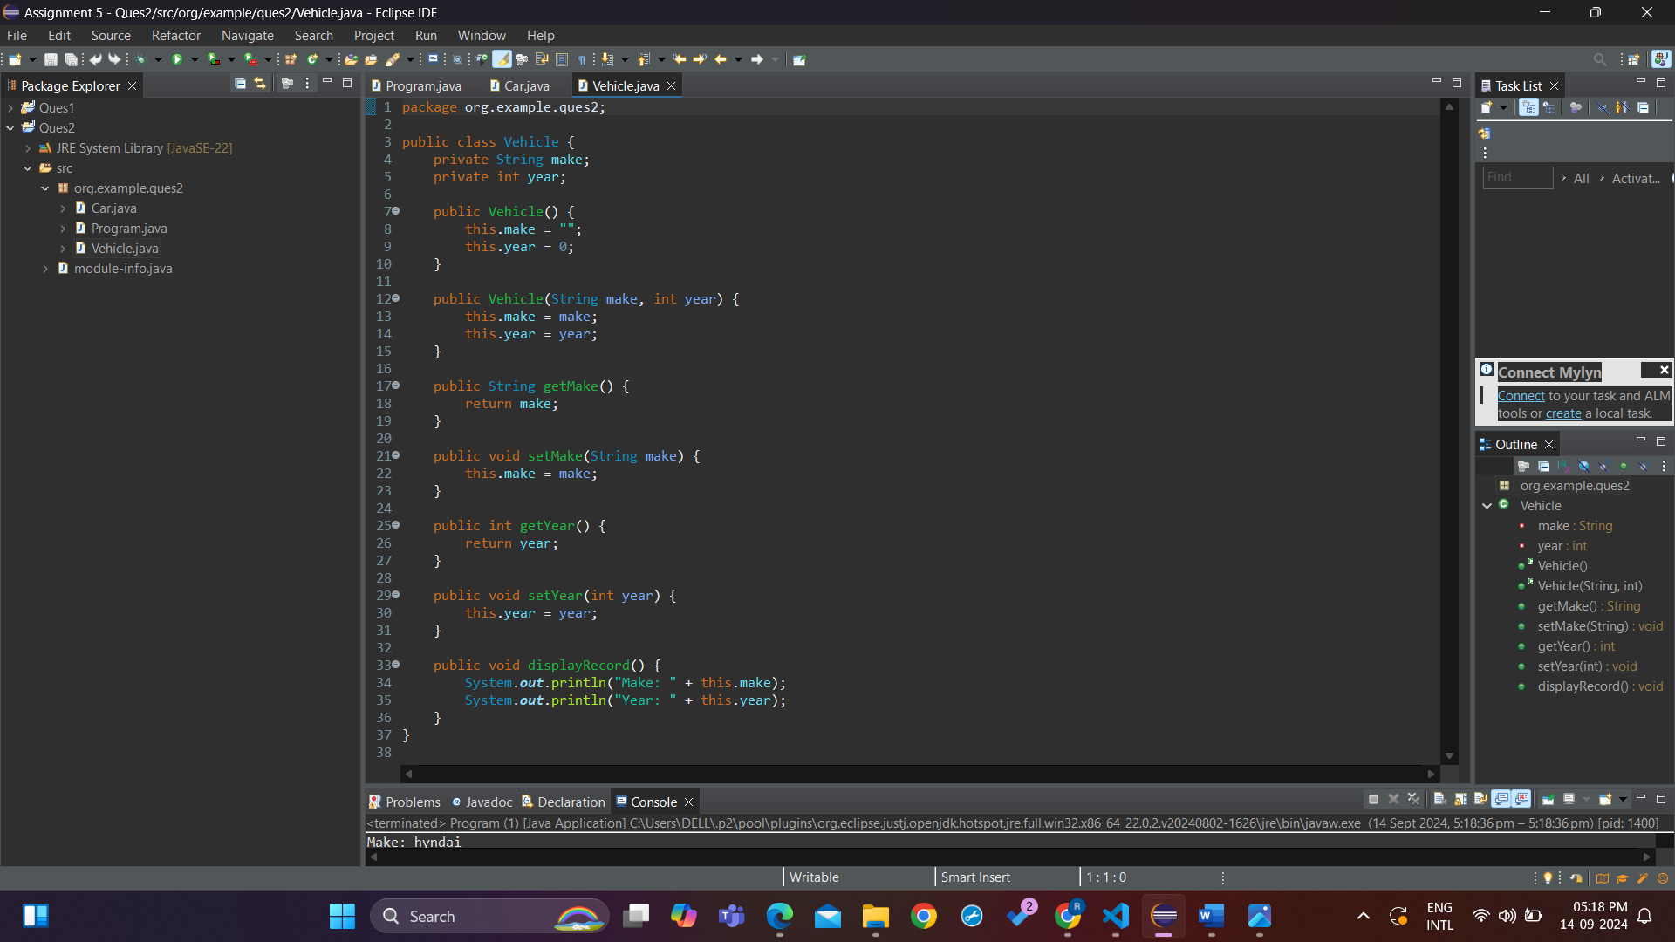

1. Create a base class Animal with attributes like name, and methods like eat() and sleep(). Create a subclass Dog that inherits from Animal and has an additional method bark(). Write a program to demonstrate the use of inheritance by creating objects of Animal and Dog and calling their methods.

Code:

package org.example.ques3;

public class Program {

public static void main(String[] args) {

Animal a1 = new Animal("cat");

a1.eat();

a1.sleep();

Dog d1 = new Dog("Tommy");

d1.bark();

Animal a2 = new Dog("Peter"); //Upcasting

a2.eat();

a2.sleep();

}

}

package org.example.ques3;

public class Animal {

private String name;

public Animal(String name) {

this.name = name;

}

public void eat() {

}

public void sleep() {

}

}

package org.example.ques3;

public class Dog extends Animal{

public Dog(String name) {

super(name);

}

public void bark() {

}

}

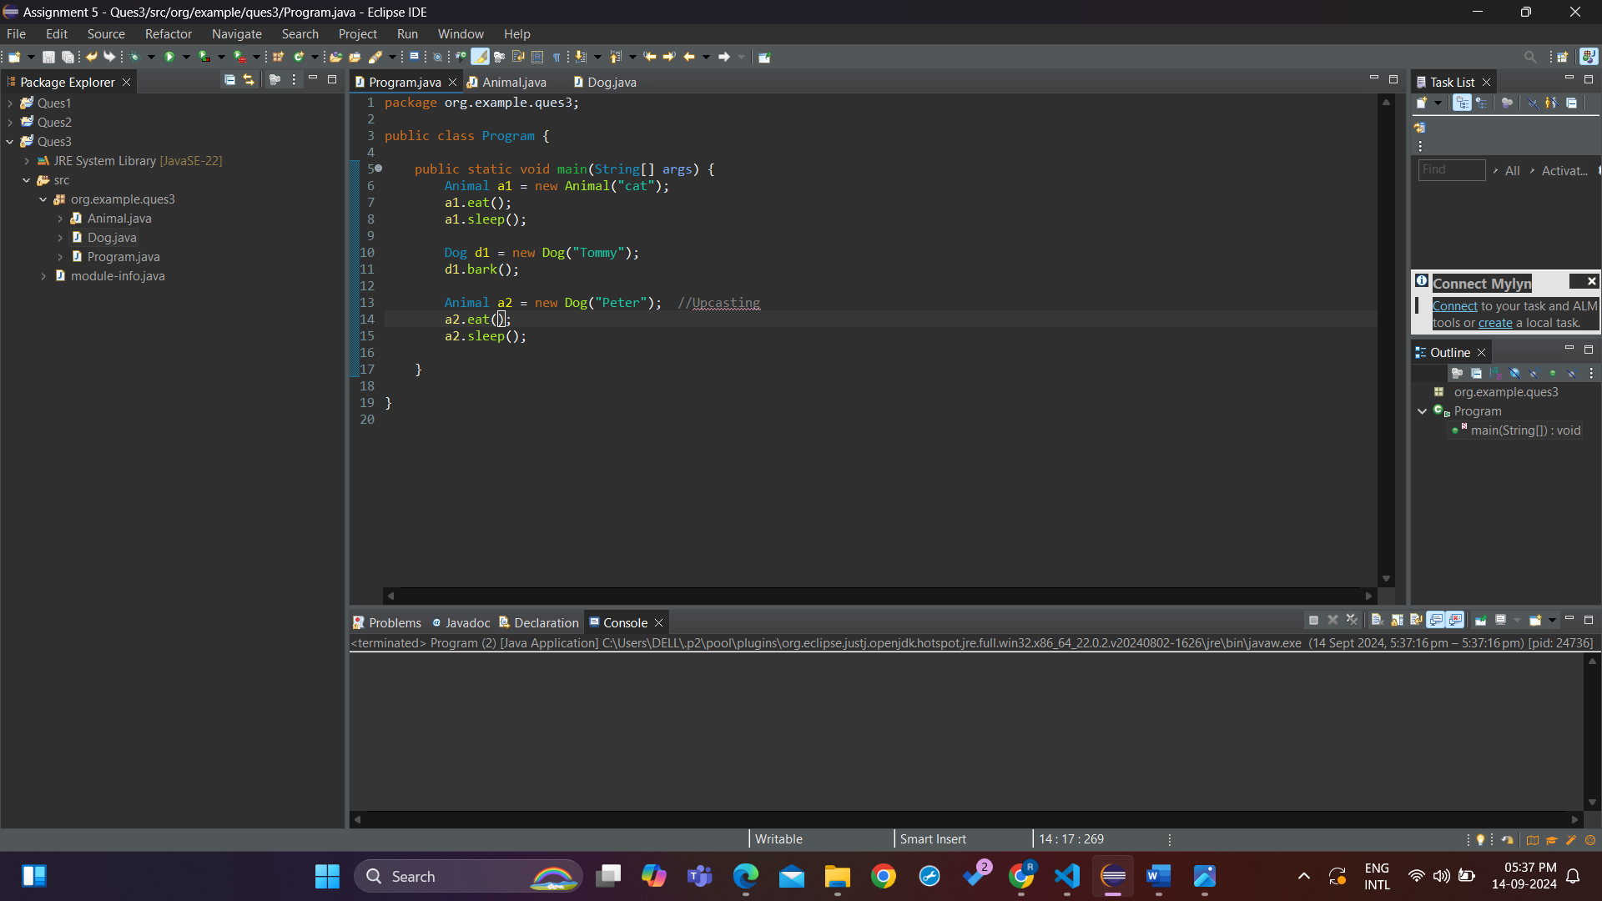

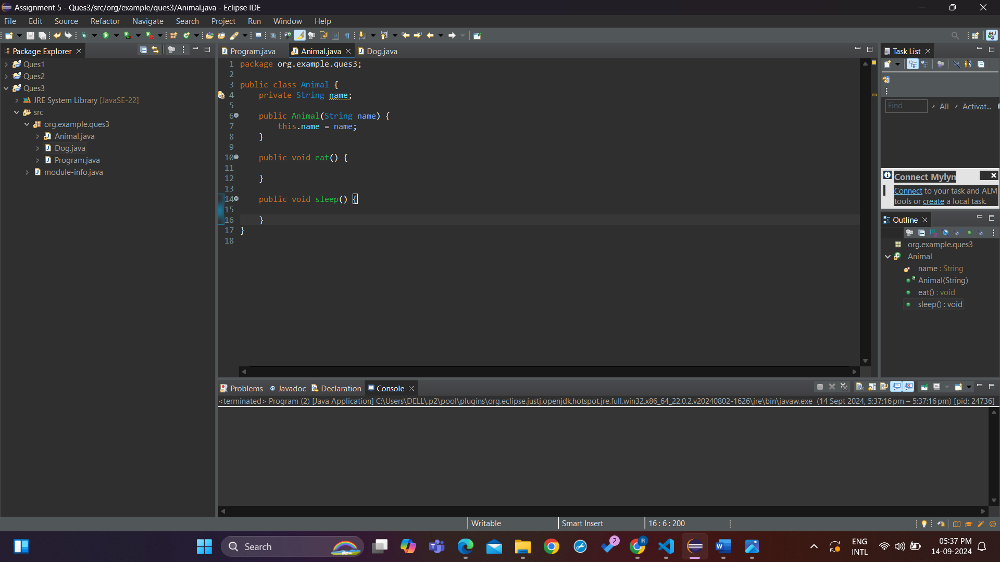

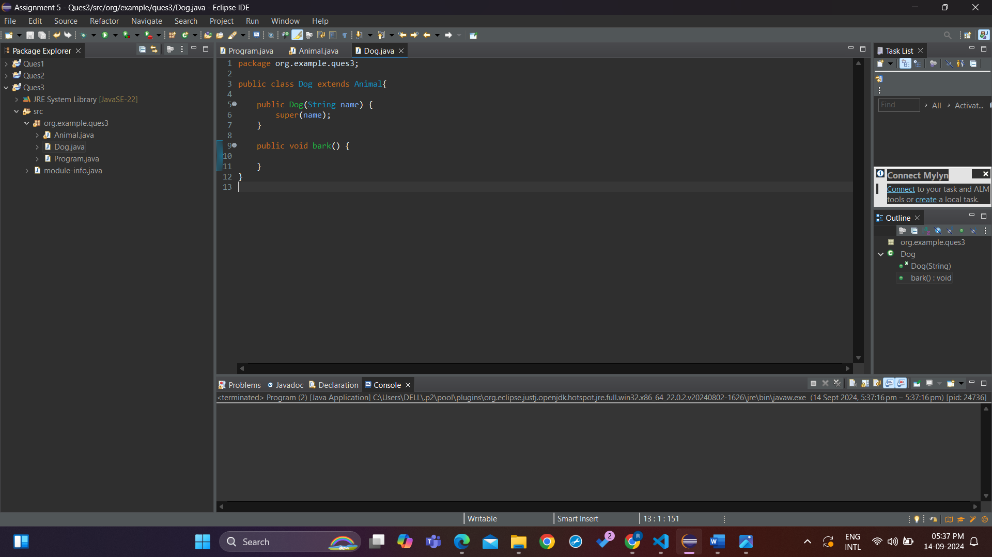

1. Build a class Student which contains details about the Student and compile and run its

instance.

Code:

package org.example.ques4;

public class Program {

public static void main(String[] args) {

Student s1 = new Student("Rahul", 22, "B.Tech", 4);

s1.displayRecord();

}

}

package org.example.ques4;

public class Student {

private String name;

private int age;

private String course;

private int year;

public Student(String name, int age, String course, int year) {

this.name = name;

this.age = age;

this.course = course;

this.year = year;

}

public String getName() {

return name;

}

public void setName(String name) {

this.name = name;

}

public int getAge() {

return age;

}

public void setAge(int age) {

this.age = age;

}

public String getCourse() {

return course;

}

public void setCourse(String course) {

this.course = course;

}

public int getYear() {

return year;

}

public void setYear(int year) {

this.year = year;

}

public void displayRecord() {

System.***out***.println("Name: " + this.name);

System.***out***.println("Age: " + this.age);

System.***out***.println("Course: " + this.course);

System.***out***.println("Year: " + this.year);

}

}

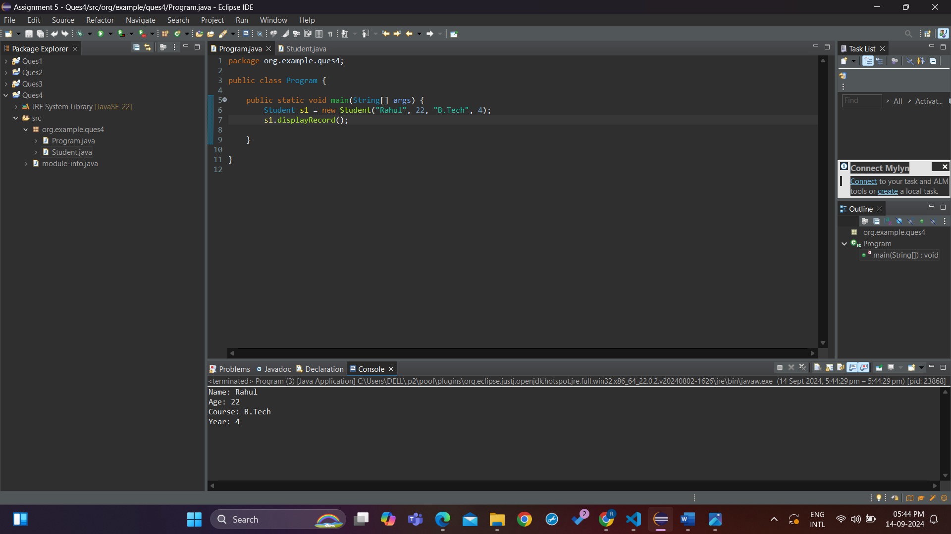

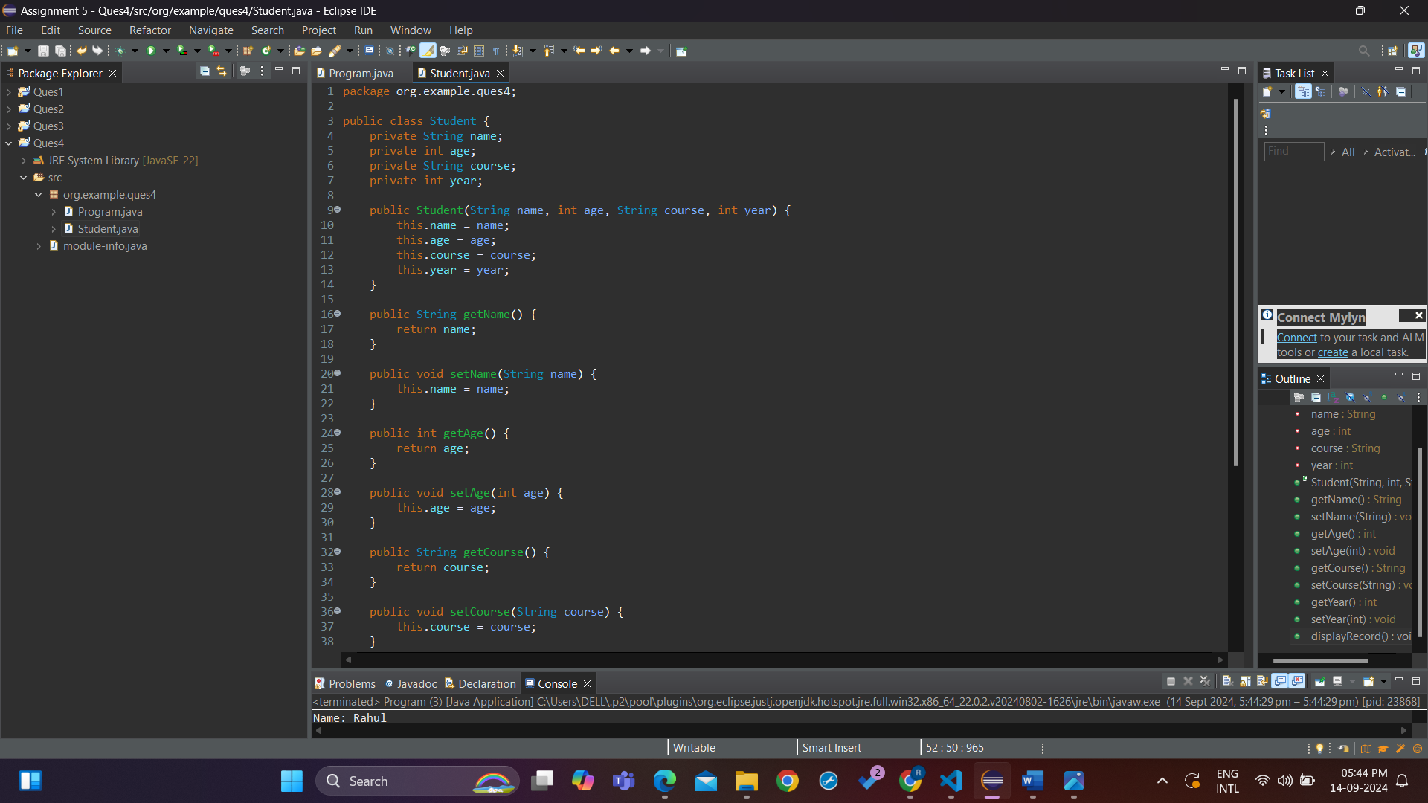

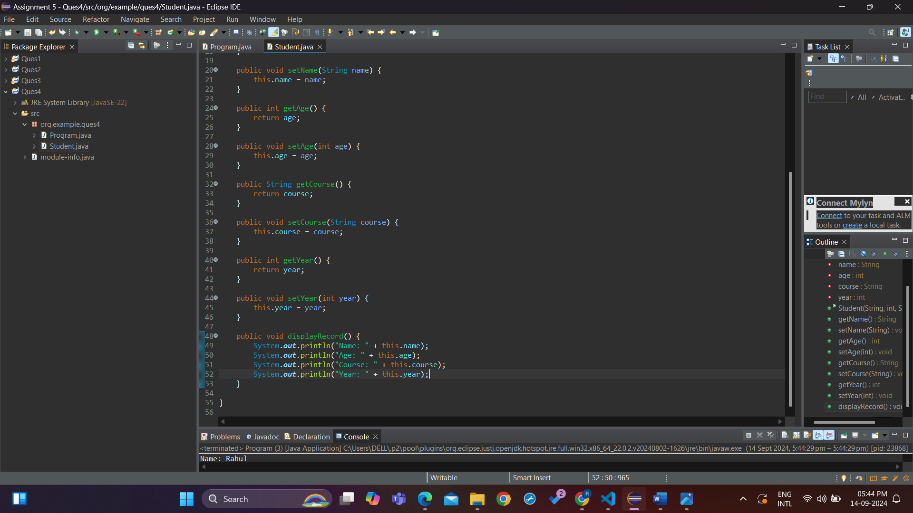

1. Write a Java program to create a base class Vehicle with methods startEngine() and stopEngine(). Create two subclasses Car and Motorcycle. Override the startEngine() and stopEngine() methods in each subclass to start and stop the engines differently

Code:

package org.example.ques5;

public class Program {

public static void main(String[] args) {

Motorcycle m1 = new Motorcycle("RE", "Classic 350 ", 2024);

m1.startEngine();

m1.startEngine();

Car c1 = new Car("Hyndai", "i20", 2019);

c1.startEngine();

c1.startEngine();

}

}

package org.example.ques5;

public class Vehicle {

String company;

String model;

int year;

public Vehicle(String company, String model, int year) {

this.company = company;

this.model = model;

this.year = year;

}

public void startEngine() {

System.***out***.println("Engine started");

}

public void stopEngine() {

System.***out***.println("Engine stopped");

}

}

package org.example.ques5;

public class Car extends Vehicle {

public Car(String company, String model, int year) {

super(company, model, year);

}

*@Override*

public void startEngine() {

System.***out***.println("Car engine has started");

}

*@Override*

public void stopEngine() {

System.***out***.println("Car engine has stopped");

}

}

package org.example.ques5;

public class Motorcycle extends Vehicle {

public Motorcycle(String company, String model, int year) {

super(company, model, year);

}

*@Override*

public void startEngine() {

System.***out***.println("Motorcycle engine has started");

}

*@Override*

public void stopEngine() {

System.***out***.println("Motorcycle engine has stopped");

}

}

